Lesson Highlight: Just Right Books
June 19, 2014Annual Report, Collaboration, ELA, Instruction, Parents
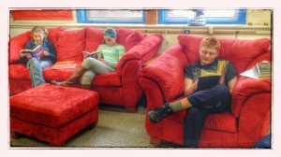
Many middle school readers are challenged by the concept of choosing “just-right” books. These are books that interest them and are at a challenging, but not impossible, reading level. There are several methods for teaching book selection to younger students, such as the five finger method. Most middle schoolers know these methods but they don’t use them because they’re not really age appropriate. A teacher approached me about teaching a more middle school appropriate method of book selection, addressing the importance of challenging reading skills and acknowledging the power of personal interest in the topic.
I developed and taught a lesson that was engaging and effective in explaining this topic. It involved comparing reading to exercise. I brought three sets of hand weights to the library: two-pound, eight-pound, and fifty-pound (I had help carrying those up from the fitness room!). I also brought exercise mats for the students to sit on, and the teacher and I dressed in workout wear to reinforce the theme.
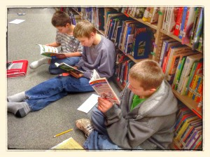
I have never enjoyed exercise, and I have very little natural athletic talent, but I have exercised regularly since high school because I understand its benefits. I explained to the students that when I exercise, I don’t compare myself to the other person in the gym or on the road. I’m only looking to improve, and the only way to improve is by constantly challenging myself. We discussed what would happen if I never exercised. I then demonstrated an exercise using the two-pound weights and they could clearly see that it was much too easy. Then I attempted the same exercise with the fifty-pound giants, and it was instantly clear that this would only lead to frustration and probably injury. Then I showed how the eight-pound weights were an appropriate challenge, and using them regularly would lead to growth at a healthy rate.
I then challenged them to think about what this had to do with them as readers. They clearly saw how the right book for them was like the right weight: something they could complete with effort. They saw that what was right for me might not be right for someone else. They also made the connection that challenging themselves with books was like challenging themselves with exercise. It would lead to growth and the ability to read more challenging material in the future.
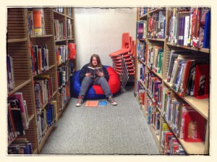
Next, we addressed interest. We brainstormed a list of cardio exercises, such as swimming, running, and soccer. When we had a long list, I explained that I needed to choose an exercise to do that evening after school. I established my parameters for the workout: it had to be do-able in 45 minutes, it could not involve travel as I had to be back at school for meetings later, it had to be an appropriate challenge for me, and it had to be something I could do alone. We looked at the list and crossed off those that didn’t fit. I clearly couldn’t ski, for instance, because it wasn’t winter. I modeled my thought process for choosing a workout from the list. Then I helped them abstract this thought process to book selection. If I had skipped the workout because I had my heart set on swimming but I had no pool, I would not become any stronger. If the one book they want is checked out, or the teacher requires a certain genre that isn’t their favorite, they need to make the best choice within the parameters they are given in order to become stronger readers.
At the end of the lesson, students were encouraged to come up and try the various weights to reinforce the concept of effort with their kinesthetic sense. The students left the library and went to class to choose books for literature circles, and the teachers reported that the students took their time selecting books and chose appropriately challenging books that they enjoyed. The exercise analogy we created was relevant to their experiences and helped them use the book selection skill in the classroom.
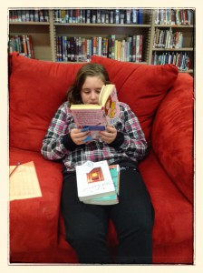
http://district.rsu10.org/mvmsmc/2014/06/19/lesson-highlight-just-right-books/

